Glucagon can’t hurt the student – IT IS LIFE-SAVING. Glucagon raises the blood sugar by releasing stored sugar from the liver. Only use the syringe that comes with the kit – DO NOT use an insulin syringe.
Explanation/Return Demonstration
A. States purpose of glucagon procedure and location of student’s glucagon emergency kit in the school. Kit is kept at room temperature.

B. The IHP is referenced and necessary interventions are followed.

C. Identifies supplies - Glucagon Emergency Kit.

D. Procedure:
1. Verify signs of severe low blood sugar: unconscious/unresponsive and/or seizures.

2. CALL 911 and then direct other staff to contact parent and District RN

3. Place student on side. If student on pump, disconnect at site on skin (peel off like a band-aid). Pump to remain with student. Adult staff must remain with student.

4. Refer to prescription label on glucagon kit or ISHP for dosage.

E. Prepare and Administer Glucagon injection:
a. Flip cap off vial. Remove needle cover.

b. Insert needle through rubber stopper on vial of glucagon. Use only the needle contained with the kit.

c. Inject entire contents of syringe (sterile water) into glucagon powder.

d. Without removing needle, hold syringe and vial together and gently swirl until contents of vial are dissolved/clear. Do not shake vial.

e. Hold vial upside down and withdraw solution into syringe to amount marked on syringe.

f. Without removing needle, check for air bubbles and inject air back into bottle, then withdraw correct amount of solution.

g. Locate site for injection, mid-thigh, while holding syringe like a pen or a dart.

h. Insert needle at 90 degree angle quickly into skin (may be injected through clothing). Inject glucagon solution.
- Count to 5 before removing.

I. Place used syringe in empty glucagon case and close case. Do not recap needle.

J. Write down time given on glucagon case and give to paramedics.

F. Stay with student until paramedics arrive. Maintain side lying position, student may vomit.

G. Until 911 arrives- once student responds to glucagon and is able to sit-up, treat with glucose gel. When fully alert offer sips of juice or regular soda.

H. Document glucagon administration on Student Daily Diabetes Monitoring Log and Health Room Log.

ADMINISTRATION OF GLUCAGON Quick Reference Sheet
Severe Low Blood Sugar- student is unconscious/unresponsive and/or having a seizure. Call 911. Designate someone to call if available.
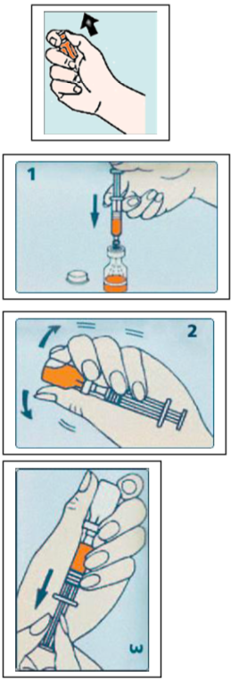
Position student on side.
PREPARATION
- Open kit and remove vial and syringe.
- Flip cap off vial (glass bottle) of glucagon dry powder.
MIXING SOLUTION
- Remove hard plastic and gray rubber cap from syringe.
- Insert needle through rubber stopper on vial of glucagon
- Inject entire contents of syringe into vial of powder. (Pic 1)
- Without removing the syringe, hold syringe and vial in one hand and gently swirl until all powder is dissolved and solution is clear. (Pic 2)
WITHDRAWING SOLUTION
- Inspect: Solution must be clear and colorless.
- Hold vial upside down
- Slowly withdraw the amount of solution from the vial
Draw up ______________________ of glucagon (Pic 3) (Dosage)
INJECTING THE GLUCAGON
May give through clothes
- Locate site for injection on mid thigh. Avoid clothing seams and pockets.
- Hold site with one hand while holding syringe like a pen or a dart.
- Insert at 90 degree angle and inject the Glucagon solution.
- Remove and put used syringe with exposed needle into empty Glucagon case.
- Close case and give to EMS for disposal.
- Note time.
- Vomiting may occur after injection.
- May take 10-15 minutes before improvement is apparent. Be sure parent has been called.

