Gvoke is available in 2 different delivery methods. The Gvoke HypoPen (auto-injector) and the Gvoke pre-filled syringe require no preparation, no mixing prior to being administered. These devices are kept at room temperature. Gvoke can’t hurt the student – IT IS LIFE-SAVING. Gvoke raises the blood sugar by releasing stored sugar from the liver.
Explanation/Return Demonstration for both PFS and HypoPen
A. States purpose of Gvoke procedure and location of student’s Gvoke in the school. Gvoke is kept at room temperature.
B. The ISHP is referenced and necessary interventions are followed.
C. Identifies supplies – Gvoke HypoPen or Gvoke pre-filled syringe(PFS)
D. Procedure:
1. Verify signs of severe low blood sugar: unconscious/unresponsive and/or seizures.
2. Direct other staff to call CALL 911 and then parent and District RN
3. If student on pump, disconnect at site on skin (peel off like a band-aid). Pump to remain with student. Adult staff must remain with student.
4. Refer to prescription label on Gvoke or ISHP for dosage.
E. Prepare and Administer Gvoke injection with pre-filled syringe (PFS):
1. Tear open pouch at the dotted line and carefully remove the Gvoke PFS.
2. Check the expiration date printed on the label of the Gvoke PFS.
3. Inspect the solution through the viewing window; it is normal to see air bubbles.
4. Pinch skin of lower abdomen, outer thigh, or outer upper arm. Insert needle at 90 degrees. Push plunger down to inject.
5. Turn the student on his or her side.
E. Prepare and Administer Gvoke injection with HypoPen:
1. Tear open pouch at the dotted line and carefully remove the Gvoke HypoPen.
2. Check the expiration date printed on the label of the Gvoke HypoPen
3. Look at the liquid medicine through the viewing window. It must be clear and colorless, or a pale yellow.
4. Choose the abdomen, thigh, or outer upper arm for the injection site.
The injection must be given directly into skin. It cannot be given through clothing!
5. Pull the red needle cap straight off the device.
6. Push and hold the Gvoke HypoPen (yellow end) straight down against the injection site. Listen for a “click”
7. Continue to hold the device down and count slowly to 5.
8. When the injection is complete, the viewing window will be red.
9. Lift the device straight up from the injection site. The yellow needle guard will lock over the needle.
10. Turn the student on his or her side.
F. Stay with student until paramedics arrive. Maintain side lying position, student may vomit. Dispose of PFS or HypoPen in SHARPS container.

G. Until 911 arrives- once student responds to Gvoke (glucagon) and is able to sit-up, treat with glucose gel. When fully alert offer sips of juice or regular soda.

H. Document Gvoke administration on Student Daily Diabetes Monitoring Log and Health Room Log.

Diagrams for both devices on next page:

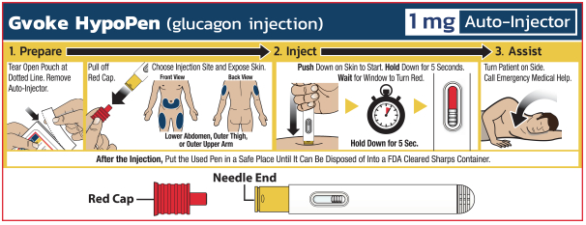

ADMINISTRATION OF Gvoke PFS Quick Reference Sheet
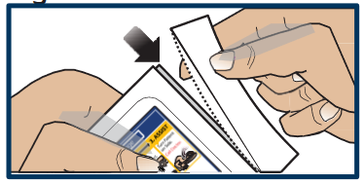
PREPARATION
1. Tear open pouch at the dotted line and carefully remove the GVOKE PFS.
2. Check the expiration date printed on the label of the GVOKE PFS.
3. Inspect the solution through the viewing window; it is normal to see air bubbles.
INJECTING THE GLUCAGON
- Pull off needle cap
- Pinch skin of lower abdomen, outer thigh or outer upper arm.
- Insert needle at 90 degrees.
- Push plunger down to inject.
- Remove and put used syringe with exposed needle into sharps container.
- Note time
- Vomiting may occur after injection.
- May take 10-15 minutes before improvement is apparent. Be sure parent has been called.
