GVOKE can’t hurt the student – IT IS LIFE-SAVING. GVOKE raises the blood sugar by releasing stored sugar from the liver.
Explanation/Return Demonstration
A. States purpose of GVOKE procedure and location of student’s GVOKE in the school. GVOKE is kept at room temperature.

B. The IHP is referenced and necessary interventions are followed.
C. Identifies supplies – GVOKE.
D. Procedure:
1. Verify signs of severe low blood sugar: unconscious/unresponsive and/or seizures.
2. CALL 911 and then direct other staff to contact parent and District RN
3. Place student on side. If student on pump, disconnect at site on skin (peel off like a band-aid). Pump to remain with student. Adult staff must remain with student.
4. Refer to prescription label on Gvoke or IHP for dosage.

E. Prepare and Administer GVOKE injection:
1. Tear open pouch at the dotted line and carefully remove the GVOKE PFS.
2. Check the expiration date printed on the label of the GVOKE PFS.
3. Inspect the solution through the viewing window; it is normal to see air bubbles.
4. Pinch skin of lower abdomen, out thigh, or outer upper arm. Insert needle at 90 degrees. Push plunger down to inject.
5. Turn the student on his or her side.

F. Stay with student until paramedics arrive. Maintain side lying position, student may vomit.
G. Until 911 arrives- once student responds to glucagon and is able to sit-up, treat with glucose gel. When fully alert offer sips of juice or regular soda.
H. Document GVOKE administration on Student Daily Diabetes Monitoring Log and Health Room Log.

Administration Reference Guide next page

Colorado Kids with Diabetes Care and Prevention Collaborative Apr 2020

ADMINISTRATION OF Gvoke Quick Reference Sheet
Severe Low Blood Sugar- student is unconscious/unresponsive and/or having a seizure. Call 911. Designate someone to call if available.
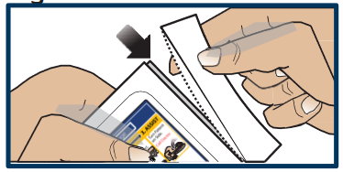
Position student on side.
PREPARATION
1. Tear open pouch at the dotted line and carefully remove the GVOKE PFS.
2. Check the expiration date printed on the label of the GVOKE PFS.
3. Inspect the solution through the viewing window; it is normal to see air bubbles.
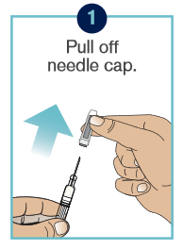
INJECTING THE GLUCAGON
- Pull off needle cap
- Pinch skin of lower abdomen, outer thigh or outer upper arm.
- Insert needle at 90 degrees.
- Push plunger down to inject.
- Remove and put used syringe with exposed needle into sharps container.
- Close case and give to EMS for disposal.
- Note time.
- Vomiting may occur after injection.
- May take 10-15 minutes before improvement is apparent. Be sure parent has been called.
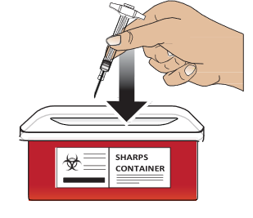
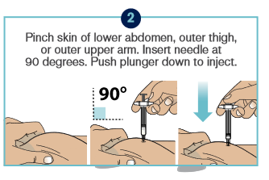

Colorado Kids with Diabetes Care and Prevention Collaborative Apr 2020

