Baqsimi Nasal Glucagon can’t hurt the student – IT IS LIFE-SAVING. Baqsimi raises the blood sugar by releasing stored sugar from the liver.
Explanation/Return Demonstration

A. States purpose of Baqsimi Nasal Glucagon procedure and location of student’s Baqsimi in the school. Baqsimi is kept at room temp.
B. The Individualized Health Plan (IHP) is referenced and necessary interventions are followed.
C. Identifies supplies - Baqsimi Nasal Glucagon Kit. This product needs to stay sealed until right before use

D. Procedure:
1. Verify signs of severe low blood sugar: unconscious/unresponsive and/or seizures. (If you can access a blood sugar reading or CGM reading please do if glucometer or receiver available.)
2. Direct other staff to Call 911 then contact parent
3. Place student on side. If student on pump, disconnect at site on skin (peel off like a band-aid). Pump to remain with student. Adult staff must remain with student.

E. Prepare and Administer Baqsimi Nasal Glucagon injection:
a. Remove the Shrink Wrap by pulling on the red stripe.
b. Open the Lid and remove the Device from the Tube.
CAUTION: DO not press the Plunger until ready to give the dose.
c. Hold device between fingers and thumb. DO NOT push Plunger yet.
d. Insert Tip gently into one nostril until finger(s) touch the outside of the nose.
e. Push Plunger firmly all the way in. Dose is complete when the Green Line Disappears.
f. Place used device into the tube and write down time given on glucagon tube and give to paramedics.

F. Stay with student until paramedics arrive. Maintain side lying position, student may vomit.

G. Until 911 arrives- once student responds to glucagon and is able to sit-up, treat with glucose gel. When fully alert
offer sips of juice or regular soda.

H. If no return to consciousness, may repeat dose in 15 minutes if second dose is on hand
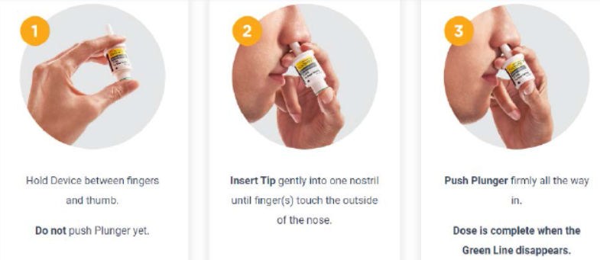
I. Document Baqsimi Nasal Glucagon administration on Medication Agreement form. Notify District RN

